Criterion D: Knowledge and Understanding
Authentic Real-life Situation

Level | Descriptors for this test
0 | Your work does not reach a standard described below.
1 – 2 | You are able to identify some of the elements of the problem, apply mathematical strategies to find a solution to the authentic real-life situation, with limited success.
3 – 4 | You are able to identify the relevant elements of the authentic real-life situation, select, with some success, adequate mathematical strategies to model the authentic real-life situation, apply mathematical strategies to reach a solution to the authentic real-life situation, discuss whether the solution makes sense in the context of the authentic real-life situation.
5 – 6 | You are able to identify the relevant elements of the authentic real-life situation, select adequate mathematical strategies to model the authentic real-life situation, apply the selected mathematical strategies to reach a valid solution to the authentic real-life situation, explain the degree of accuracy of the solution, and explain whether the solution makes sense in the context of the authentic real-life situation.
7 – 8 | You are able to identify the relevant elements of the authentic real-life situation, select appropriate mathematical strategies to model the authentic real-life situation, apply the selected mathematical strategies to reach a correct solution to the authentic real-life situation, justify the degree of accuracy of the solution, justify whether the solution makes sense in the context of the authentic real-life situation.

The problem: You are a young entrepreneur starting a floor tile company. You would like to sell a new line of circle patterns for floors that you have designed. Study the design features and cost of the new tiles.
Follow the steps below to do your calculation and justify your work, including any assumptions you may need to do to carry out your task. Show all your work.
In the next page are the new pattern designs “Happy circles” and “Serious circles”. The cost for manufacturing each tile is $4.15 for Serious Circles and $4.76 for Happy Circles. Each circle, in both patterns, has a diameter of 20 cm.
Your task:
- For decoration purposes, it is important to know how dark or light are the tiles. For each type of tile, calculate a number that could give a client an idea of the relationship between white area and black areas. Justify your answer.
- You are interested to know how busy each design is. What is the approximate area of a floor with 100 circles using each design? How this amount informs on how busy is the design?
- When a rectangular floor is tiled, are there any leftovers from each floor design? Explain.

- How much do tiles cost to floor a room of 7 meters by 11.5 meters? Calculate.

- How many decimal places have you used to write the results in this assessment? Justify your answer. If you decide that you choice was incorrect, write down the results properly.

- Do your results above make sense in the context of the problem? Justify your answer.
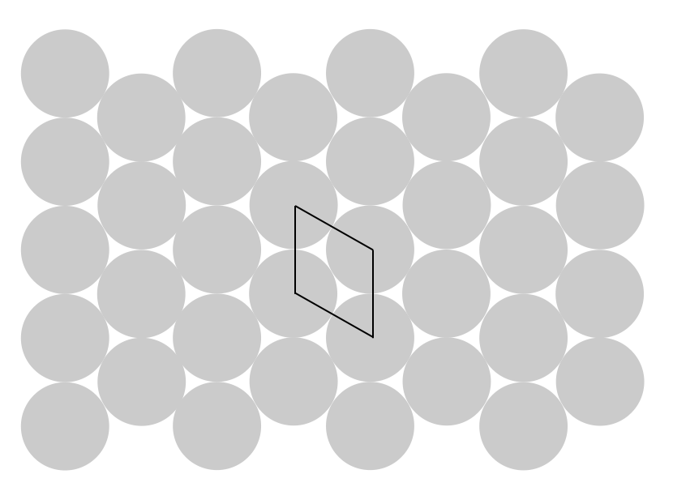
Happy Circles Design - The individual tile is shown with a solid line.
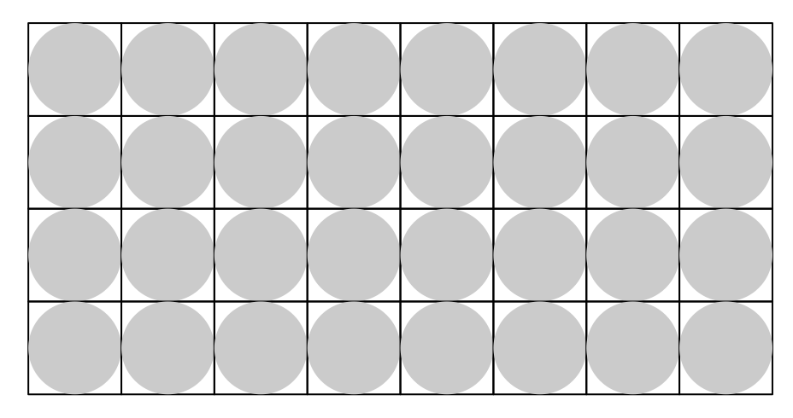
Serious circles Design - The individual tiles are shown with a solid line border.

